SEC Form 3
FORM 3 | UNITED STATES SECURITIES AND EXCHANGE COMMISSION  Washington, D.C. 20549  INITIAL STATEMENT OF BENEFICIAL OWNERSHIP OF SECURITIES  Filed pursuant to Section 16(a) of the Securities Exchange Act of 1934  or Section 30(h) of the Investment Company Act of 1940
  OMB APPROVAL
  OMB Number: | 3235-0104
  Estimated average burden
  hours per response: | 0.5
1. Name and Address of Reporting Person*  (Street) | 2. Date of Event Requiring Statement (Month/Day/Year)  08/06/2026 | 3. Issuer Name and Ticker or Trading Symbol  Editas Medicine, Inc. [ EDIT ]  Foreign Trading Symbol
  Ellinor Patrick Thomas II
  (Last) | (First) | (Middle)
  11 HURLEY STREET
  CAMBRIDGE | MA | 02141
  (City) | (State) | (Zip)
 |  | 4. Relationship of Reporting Person(s) to Issuer  (Check all applicable) | 5. If Amendment, Date of Original Filed (Month/Day/Year)
   | Director |  | 10% Owner
   | Officer (give title below) |  | Other (specify below)
6. Individual or Joint/Group Filing (Check Applicable Line)
Form filed by One Reporting Person
Form filed by More than One Reporting Person

Table I - Non-Derivative Securities Beneficially Owned
1. Title of Security (Instr. 4) | 2. Amount of Securities Beneficially Owned (Instr. 4) | 3. Ownership Form: Direct (D) or Indirect (I) (Instr. 5) | 4. Nature of Indirect Beneficial Ownership (Instr. 5)
Table II - Derivative Securities Beneficially Owned
(e.g., puts, calls, warrants, options, convertible securities)
1. Title of Derivative Security (Instr. 4) | 2. Date Exercisable and Expiration Date (Month/Day/Year) |  | 3. Title and Amount of Securities Underlying Derivative Security (Instr. 4) |  | 4. Conversion or Exercise Price of Derivative Security | 5. Ownership Form: Direct (D) or Indirect (I) (Instr. 5) | 6. Nature of Indirect Beneficial Ownership (Instr. 5)
1. Title of Derivative Security (Instr. 4) | Date Exercisable | Expiration Date | Title | Amount or Number of Shares | 4. Conversion or Exercise Price of Derivative Security | 5. Ownership Form: Direct (D) or Indirect (I) (Instr. 5) | 6. Nature of Indirect Beneficial Ownership (Instr. 5)
Explanation of Responses:
Remarks:
No securities are beneficially owned.
 | /s/ Patrick Ellinor | 08/07/2026
 | ** Signature of Reporting Person | Date
Reminder: Report on a separate line for each class of securities beneficially owned directly or indirectly.
* If the form is filed by more than one reporting person, see Instruction 5 (b)(v).
** Intentional misstatements or omissions of facts constitute Federal Criminal Violations See 18 U.S.C. 1001 and 15 U.S.C. 78ff(a).
Note: File three copies of this Form, one of which must be manually signed. If space is insufficient, see Instruction 6 for procedure.
Persons who respond to the collection of information contained in this form are not required to respond unless the form displays a currently valid OMB Number.
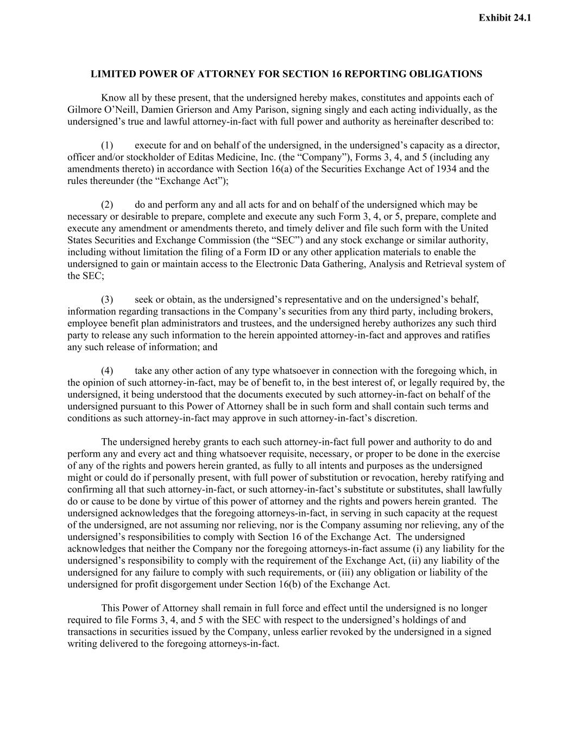
LIMITED POWER OF ATTORNEY FOR SECTION 16 REPORTING OBLIGATIONS Know all by these present, that the undersigned hereby makes, constitutes and appoints each of Gilmore O’Neill, Damien Grierson and Amy Parison, signing singly and each acting individually, as the undersigned’s true and lawful attorney-in-fact with full power and authority as hereinafter described to: (1) execute for and on behalf of the undersigned, in the undersigned’s capacity as a director, officer and/or stockholder of Editas Medicine, Inc. (the “Company”), Forms 3, 4, and 5 (including any amendments thereto) in accordance with Section 16(a) of the Securities Exchange Act of 1934 and the rules thereunder (the “Exchange Act”); (2) do and perform any and all acts for and on behalf of the undersigned which may be necessary or desirable to prepare, complete and execute any such Form 3, 4, or 5, prepare, complete and execute any amendment or amendments thereto, and timely deliver and file such form with the United States Securities and Exchange Commission (the “SEC”) and any stock exchange or similar authority, including without limitation the filing of a Form ID or any other application materials to enable the undersigned to gain or maintain access to the Electronic Data Gathering, Analysis and Retrieval system of the SEC; (3) seek or obtain, as the undersigned’s representative and on the undersigned’s behalf, information regarding transactions in the Company’s securities from any third party, including brokers, employee benefit plan administrators and trustees, and the undersigned hereby authorizes any such third party to release any such information to the herein appointed attorney-in-fact and approves and ratifies any such release of information; and (4) take any other action of any type whatsoever in connection with the foregoing which, in the opinion of such attorney-in-fact, may be of benefit to, in the best interest of, or legally required by, the undersigned, it being understood that the documents executed by such attorney-in-fact on behalf of the undersigned pursuant to this Power of Attorney shall be in such form and shall contain such terms and conditions as such attorney-in-fact may approve in such attorney-in-fact’s discretion. The undersigned hereby grants to each such attorney-in-fact full power and authority to do and perform any and every act and thing whatsoever requisite, necessary, or proper to be done in the exercise of any of the rights and powers herein granted, as fully to all intents and purposes as the undersigned might or could do if personally present, with full power of substitution or revocation, hereby ratifying and confirming all that such attorney-in-fact, or such attorney-in-fact’s substitute or substitutes, shall lawfully do or cause to be done by virtue of this power of attorney and the rights and powers herein granted. The undersigned acknowledges that the foregoing attorneys-in-fact, in serving in such capacity at the request of the undersigned, are not assuming nor relieving, nor is the Company assuming nor relieving, any of the undersigned’s responsibilities to comply with Section 16 of the Exchange Act. The undersigned acknowledges that neither the Company nor the foregoing attorneys-in-fact assume (i) any liability for the undersigned’s responsibility to comply with the requirement of the Exchange Act, (ii) any liability of the undersigned for any failure to comply with such requirements, or (iii) any obligation or liability of the undersigned for profit disgorgement under Section 16(b) of the Exchange Act. This Power of Attorney shall remain in full force and effect until the undersigned is no longer required to file Forms 3, 4, and 5 with the SEC with respect to the undersigned’s holdings of and transactions in securities issued by the Company, unless earlier revoked by the undersigned in a signed writing delivered to the foregoing attorneys-in-fact. Exhibit 24.1

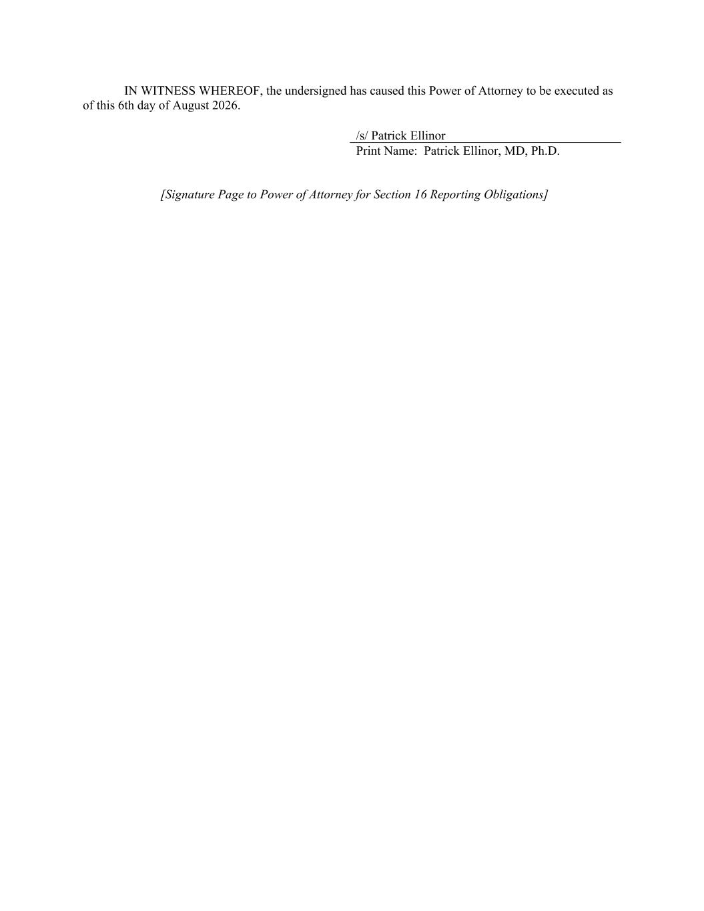
IN WITNESS WHEREOF, the undersigned has caused this Power of Attorney to be executed as of this 6th day of August 2026. /s/ Patrick Ellinor Print Name: Patrick Ellinor, MD, Ph.D. [Signature Page to Power of Attorney for Section 16 Reporting Obligations]

